2.2 Project: Software Design; Interfaces & Polymorphism
Christopher Crayton
ECPI University
SDC330L: Advanced Object-oriented Programming Using Java LAB
Dr. Helio de Castro
August 9, 2026

2.2 Project: Software Design; Interfaces & Polymorphism
Rolodex Contact Manager
- Purpose of This Document
This document lays out the overall structure of the Rolodex application - every class and interface planned for the full, five-week project, how they relate to one another, and which required object-oriented concept each one is responsible for demonstrating. It serves as the roadmap referenced in each remaining week: Week 3 adds constructors/access-specifier polish and converts Contact into an abstract class, Week 4 adds the SQLite-backed repository, and Week 5 finishes and verifies everything against the full project specification.
- Classes and Interfaces
The table below lists every class and interface in the design, its purpose, which OOP concept it primarily demonstrates, and whether it has been implemented yet or is still planned for a later week.
Class / Interface | Purpose | OOP Concept It Teaches | Status
Address | Represents a mailing address: street, city, state, zip. | Composition (composed into Contact) | Implemented - Wk 1
Contact | Base class holding fields/behavior shared by every contact type. | Inheritance (base) + Composition (has-a Address) | Implemented - Wk 1
BusinessContact | A professional contact; adds company name and job title. | Inheritance (derived) + Polymorphism (overrides displayInfo()) | Implemented - Wk 1
FamilyContact | A relative; adds relationship and birthday. | Inheritance (derived) + Polymorphism (overrides displayInfo()) | Implemented - Wk 2
FriendContact | A personal friend; adds how-we-met and favorite activity. | Inheritance (derived) + Polymorphism | Planned - Wk 3+
SocialMediaContact | A contact known mainly through social media; adds platform and username. | Inheritance (derived) + Polymorphism | Planned - Wk 3+
ContactRepository | Declares the storage operations the app needs (add, remove, update, list, search) without defining how. | Interface | Implemented - Wk 2
InMemoryContactRepository | Stores contacts in an ArrayList held in memory. | Implements ContactRepository (interface) | Implemented - Wk 2
SqliteContactRepository | Stores contacts in a SQLite database file. | Implements ContactRepository (interface) | Planned - Wk 4
App | Program entry point; displays the banner/welcome message and drives the demo. | Ties every other class together | Implemented - Wk 1-2

- Inheritance Design
The base class is Contact, which holds every field and behavior shared by all contacts: first/last name, phone number, email, a composed Address, and a displayInfo() method for printing a contact's details. Four derived classes extend Contact, each adding two fields unique to that relationship type: BusinessContact (company name, job title - implemented Week 1), FamilyContact (relationship, birthday - implemented Week 2), and FriendContact and SocialMediaContact (planned for a later week, following the same pattern). The hierarchy is intentionally shallow - a single level of inheritance from one base class - since a contact's type does not need further subdividing (e.g., there is no need for a class hierarchy under BusinessContact itself). Each derived class overrides displayInfo(), calling super.displayInfo() to reuse the shared printing logic and then appending only its own two fields, which keeps the shared formatting logic in exactly one place.
- Composition Design
Address is composed into Contact: every Contact object has-a Address object as one of its fields, rather than Contact extending Address, because an address is not a kind of contact - it's a piece of information a contact owns. This relationship needed to be composition rather than inheritance because a Contact and an Address are two genuinely different kinds of thing that are simply used together. Forcing that relationship into inheritance (e.g., Contact extends Address) would be inaccurate and would not model the real relationship. The opportunity for polymorphism here is more indirect, because every contact type composes the same Address class, a single toString() call on any contact's address formats consistently across the whole application, regardless of which Contact subclass owns it.
- Interface Design
The functionality abstracted out to an interface is contact storage: adding, removing, updating, listing, and searching contacts. This is defined in the ContactRepository interface, which declares five methods (addContact, removeContact, updateContact, getAllContacts, and getContactsByLastNameStartingWith) without specifying how any of them are carried out.
This makes sense as an interface, rather than a concrete class, because the storage mechanism is expected to change over the life of this project: Week 2 uses a simple in-memory ArrayList (InMemoryContactRepository), while Week 4 will introduce a real SQLite database (SqliteContactRepository). Because App.java only ever refers to the interface type, ContactRepository, and never to either concrete class directly, the storage mechanism can be swapped in Week 4 without changing App.java or any other class that depends on it - only a new class needs to be written.
- Polymorphism Design
Polymorphism shows up in two places in this design:
- Contact-typed references to mixed subclasses. A collection typed as List<Contact> can hold a mix of Contact, BusinessContact, and FamilyContact objects. Calling contact.displayInfo() on each element runs a different overridden version automatically, depending on each object's real runtime type - no type-checking if/else chain is needed.
- ContactRepository-typed references to different implementations. A variable declared as ContactRepository can refer to an InMemoryContactRepository today and a SqliteContactRepository in Week 4, with the exact same method calls (addContact(), getAllContacts(), etc.) working correctly against either one.
Both are demonstrated together in App.java: a ContactRepository is populated with a mix of contact subtypes, and a single loop calling displayInfo() on each retrieved contact shows three different outputs depending on each object's actual type.
- How It All Fits Together
At the top, App.java is the console entry point (to be replaced by a web-based UI in a later week, per the Week 1 UX design document). App only ever talks to the storage layer through the ContactRepository interface, never to a concrete repository class directly. Below that interface, one or more classes provide the real implementation - InMemoryContactRepository for now, joined by SqliteContactRepository in Week 4. Those repository classes work with the domain/model layer: the Contact base class and its derived contact-type subclasses, one of which composes an Address. This layering keeps each part replaceable on its own: the storage mechanism can change without touching the model classes, and the model classes can gain new contact types without touching the storage layer or the UI.
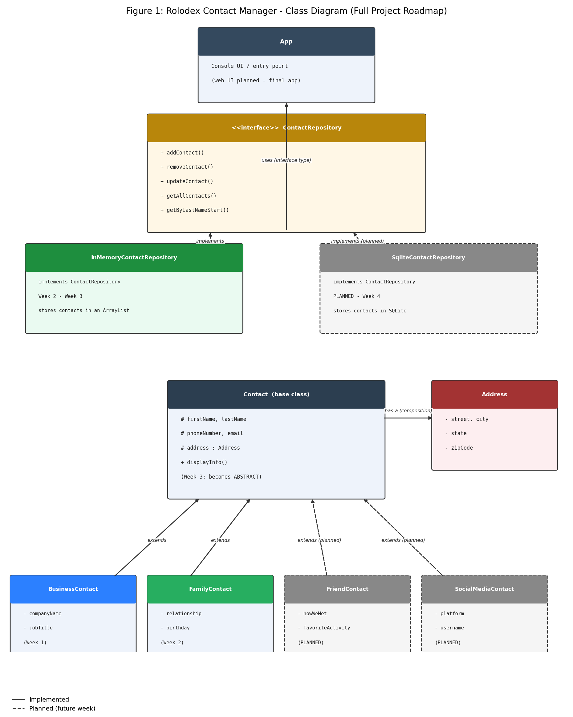
Figure 1. Full-project class diagram: solid boxes/arrows are implemented; dashed boxes/arrows are planned for a later week; generated via a Python script written with the assistance of Claude (Anthropic, 2026)
Program Screenshots
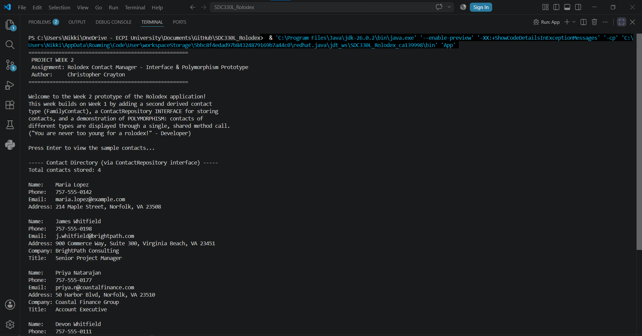
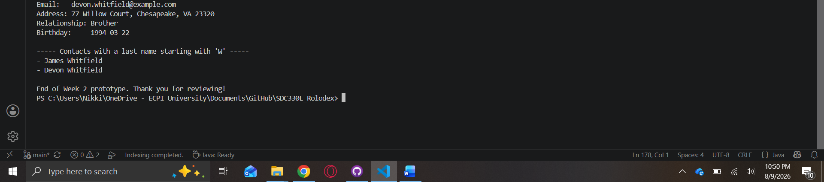

References
Anthropic. (2026). Claude (Sonnet 5) [Large language model]. https://claude.ai

